|  |  |
| --- | --- |
| **AGENCY – TEST SCENARIOS** | |
| **SCENARIO – 1** | **Verify my ticket screen with "CLAIM" remarks** |

**STEP – 1**

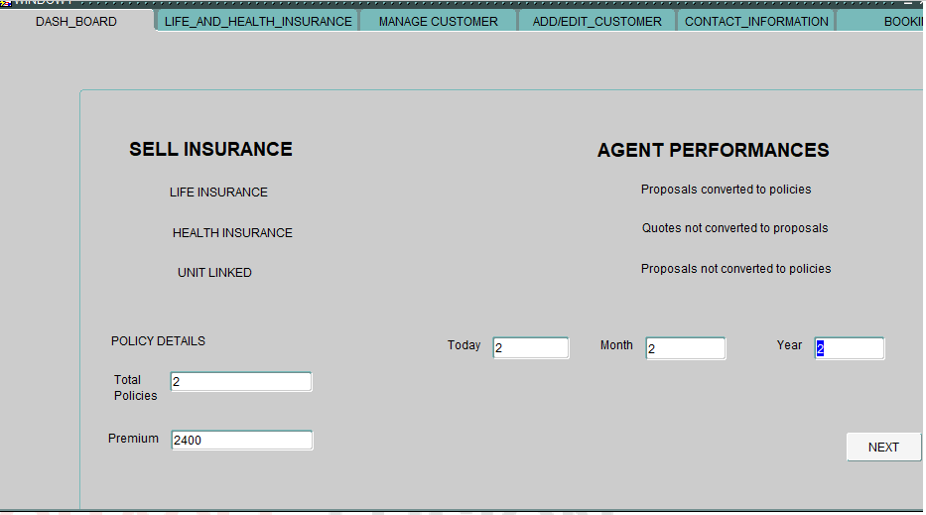

Enter the policy details.

Today, Month, Year includes the values of “total number of policies” sold by agent.

Enter the values in total policies, premium, today, month, year.

Click “NEXT” button to continue the process.

**STEP – 2**

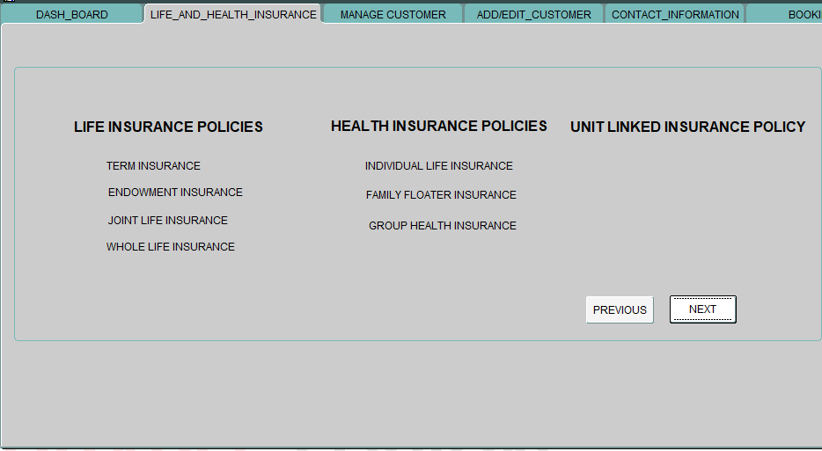

The “LIFE AND HEALTH INSURANCE” tab shows the list of life insurance, health insurance, unit linked insurance policies sold by the agent.

**STEP – 3**

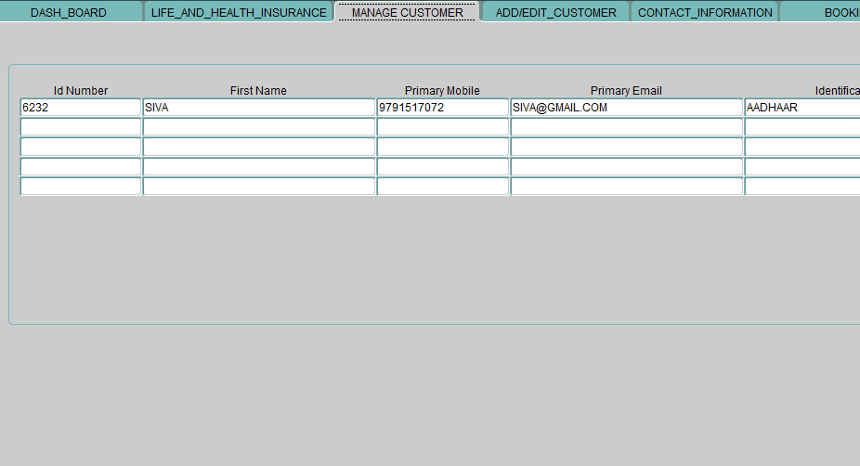

The customers who are registered by agent will be auto populated in ”MANAGE CUSTOMER” tab.

**STEP – 4**

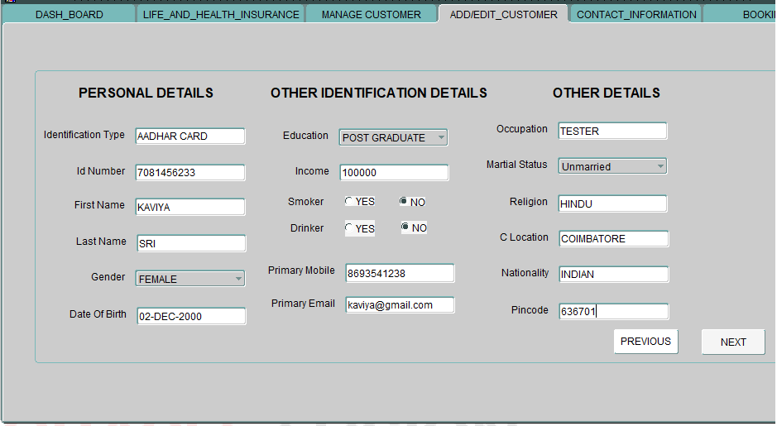

Fill the necessary details of the customer in the “ADD/EDIT CUSTOMER” tab.

Click the “NEXT” button to continue the process.

**STEP – 5**

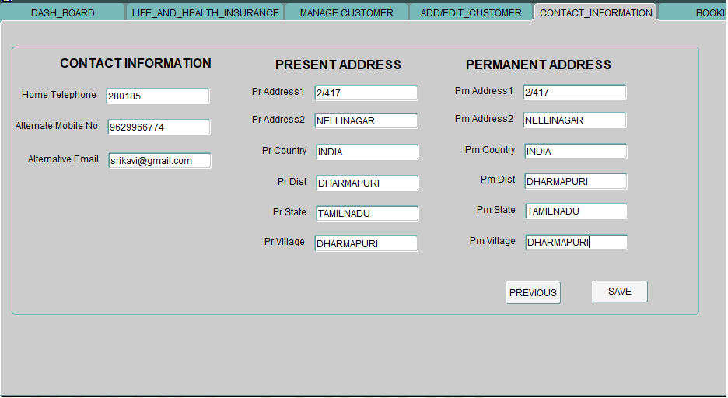

Fill the respective address details of the customer in the “CONTACT_INFORMATION” tab.

**STEP – 6**

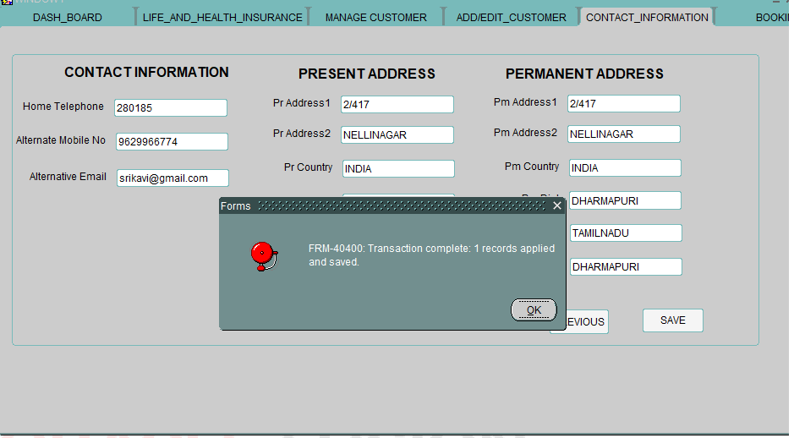

Click “SAVE” button to continue the process.

The “TRANSACTION COMPLETED” dialogue box appears.

**STEP – 7**

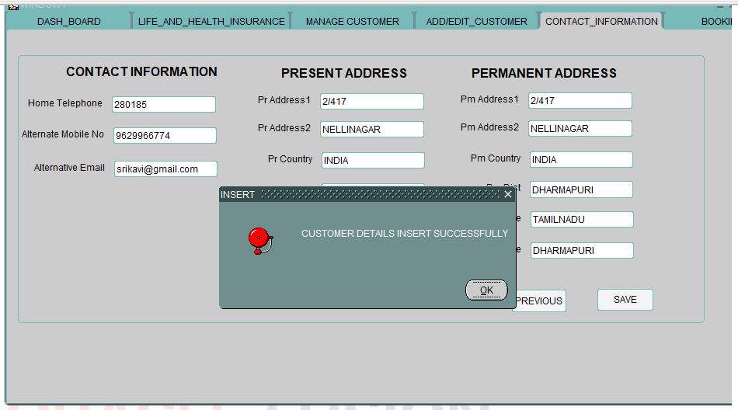

Click OK to continue.

“CUSTOMER DETAILS INSERTED SUCCESSFULLY” dialogue box appears.

**STEP – 8**

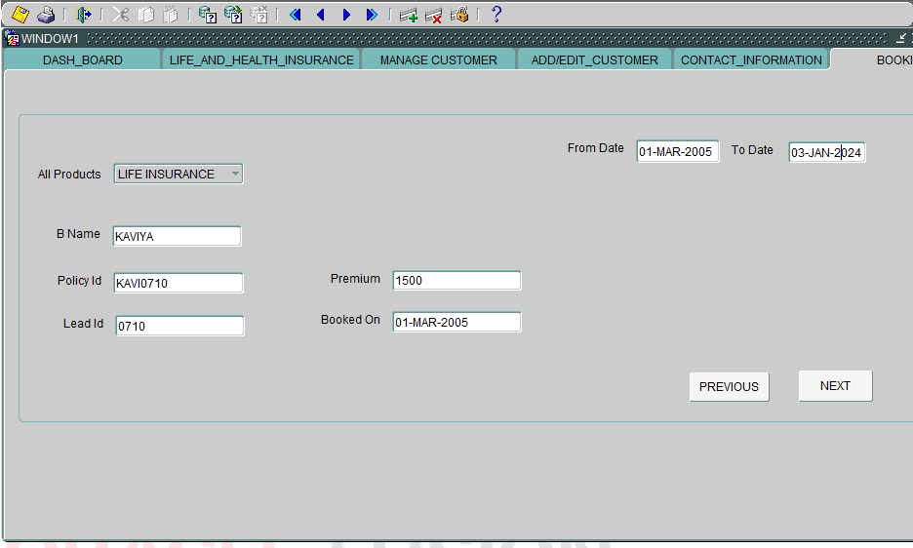

Select an insurance product from the list of values.

Enter the name, policy ID, Premium, Lead ID .

Enter the date in Booked on block.

Enter the From date, to date.

**STEP – 9**

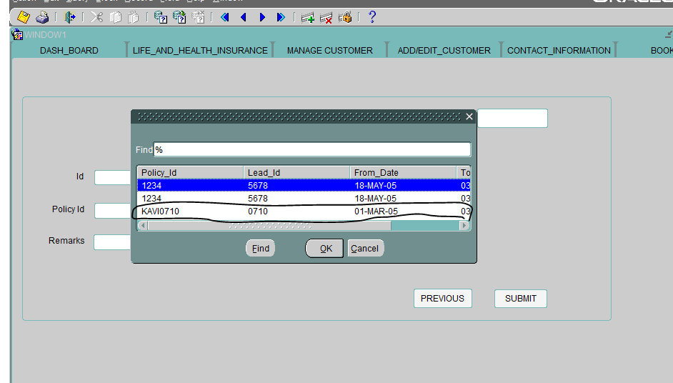

Click NEXT button to continue.

The Customer who has been registered by the agent will appear in the above dialogue box.

**STEP – 10**

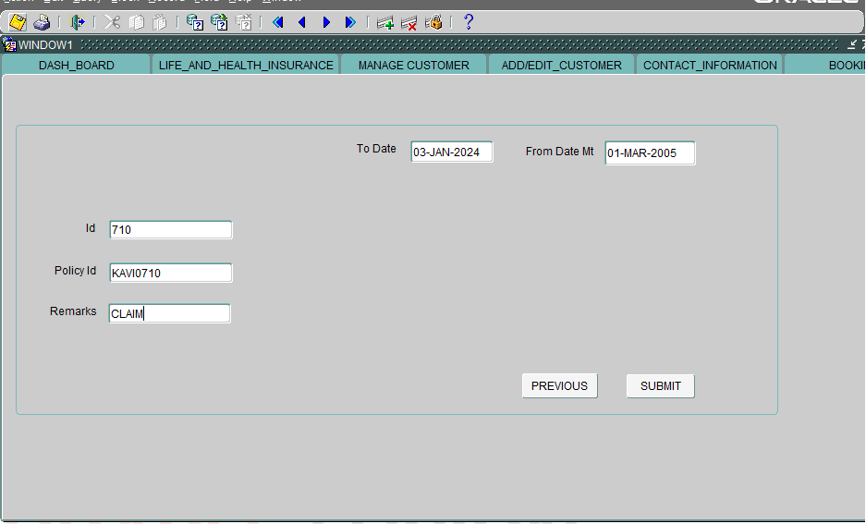

Enter the remarks as “CLAIMS”. The other details will be auto populated in my tickets screen.

**STEP – 11**

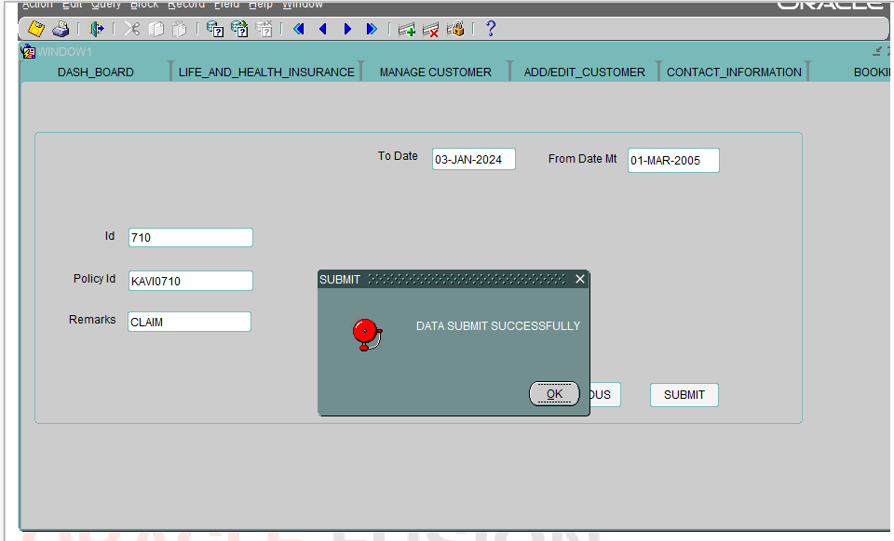

Click submit button.

The “DATA SUMIT SUCCESSFULLY” dialogue box appears.

Click OK to continue.

**STEP – 12**

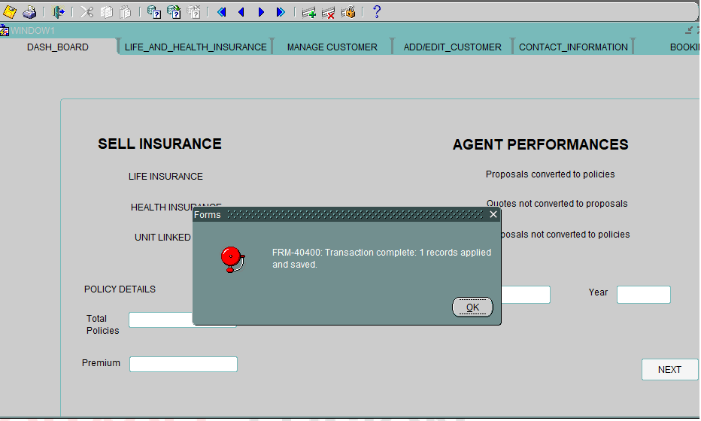

“TRANSACTION COMPLETE” dialogue box appears.

**STEP – 13**

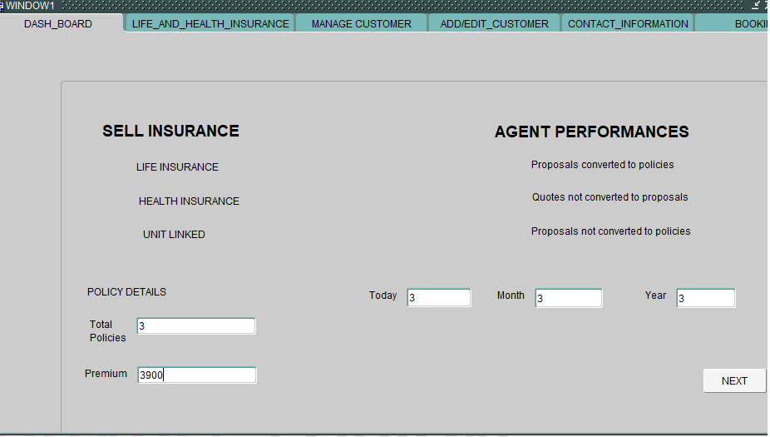

The Total policies, today, month, year, premium sold by the agent are auto populated.

|  |  |
| --- | --- |
| **AGENCY – TEST SCENARIOS** | |
| **SCENARIO – 2** | **Verify my ticket screen with "ALTERNATE" remarks** |

**STEP – 1**



Enter the policy details.

Today, Month, Year includes the values of “total number of policies” sold by agent.

Enter the values in total policies, premium, today, month, year.

Click “NEXT” button to continue the process.

**STEP – 2**



The “LIFE AND HEALTH INSURANCE” tab shows the list of life insurance, health insurance, unit linked insurance policies sold by the agent.

**STEP – 3**

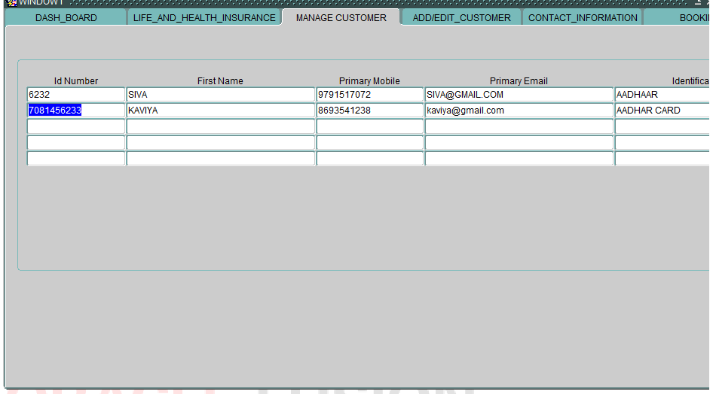

The customers who are registered by agent will be auto populated in”MANAGE CUSTOMER” tab.

**STEP – 4**

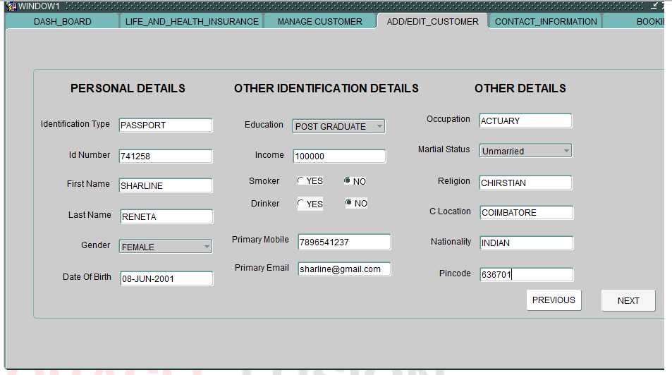

Fill the necessary details of the customer in the “ADD/EDIT CUSTOMER” tab.

Click the “NEXT” button to continue the process.

**STEP – 5**

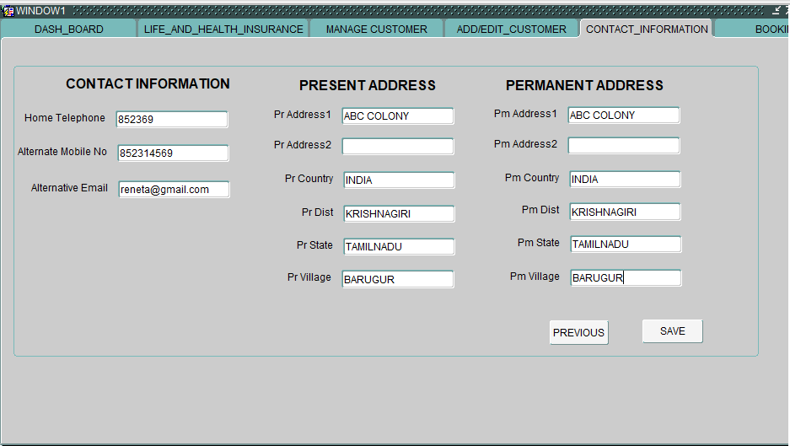

Fill the respective address details of the customer in the “CONTACT_INFORMATION” tab.

**STEP – 6**

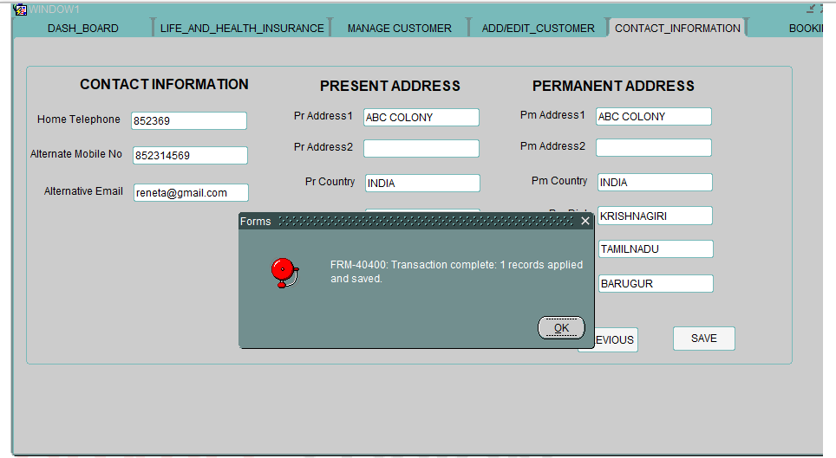

Click “SAVE” button to continue the process.

The “TRANSACTION COMPLETED” dialogue box appears.

**STEP – 7**

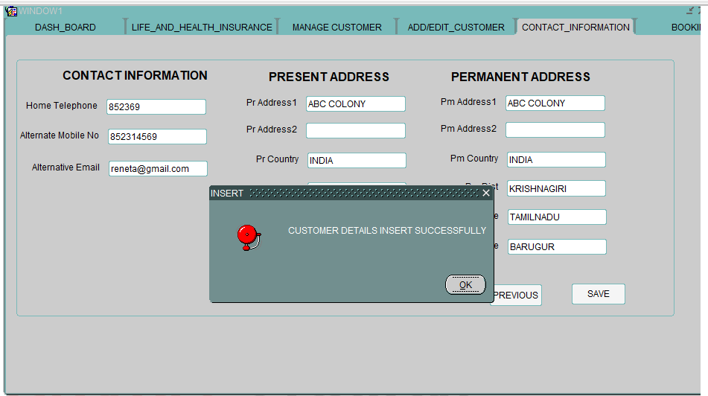

Click OK to continue.

“CUSTOMER DETAILS INSERTED SUCCESSFULLY” dialogue box appears.

**STEP – 8**

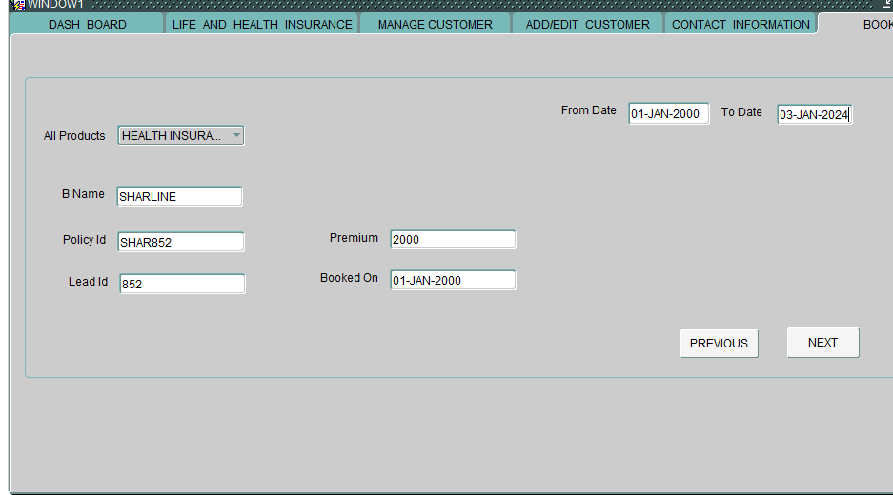

Select an insurance product from the list of values.

Enter the name, policy ID, Premium, Lead ID.

Enter the date in Booked on block.

Enter the From date, to date.

**STEP – 9**

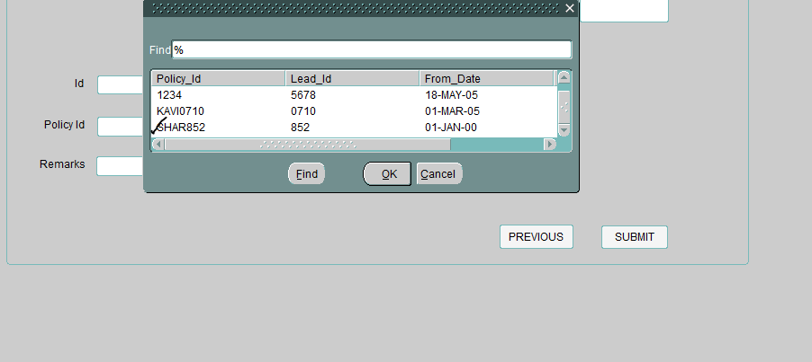

Click NEXT button to continue.

The Customer who has been registered by the agent will appear in the above dialogue box.

**STEP – 10**

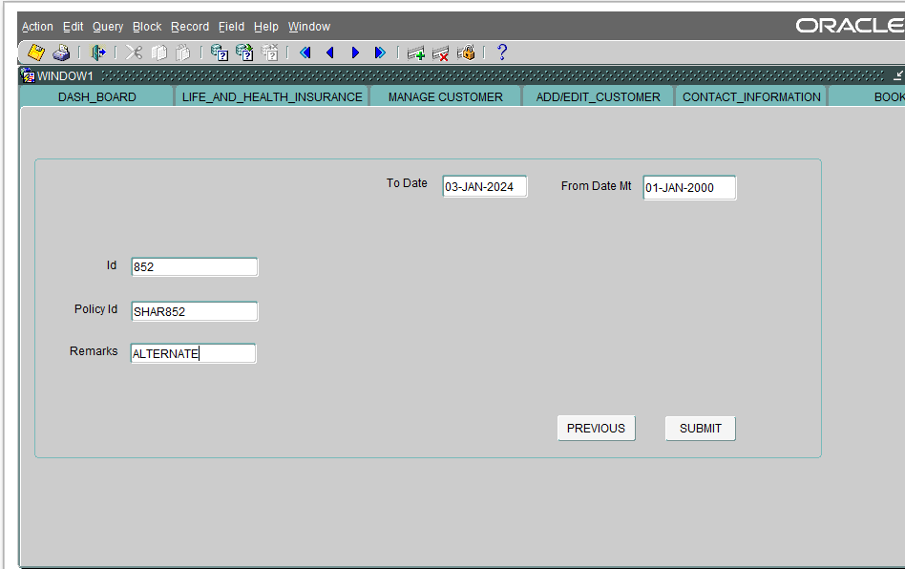

Enter the remarks as “ALTERNATE”

The other details will be auto populated in my tickets screen.]

**STEP – 11**

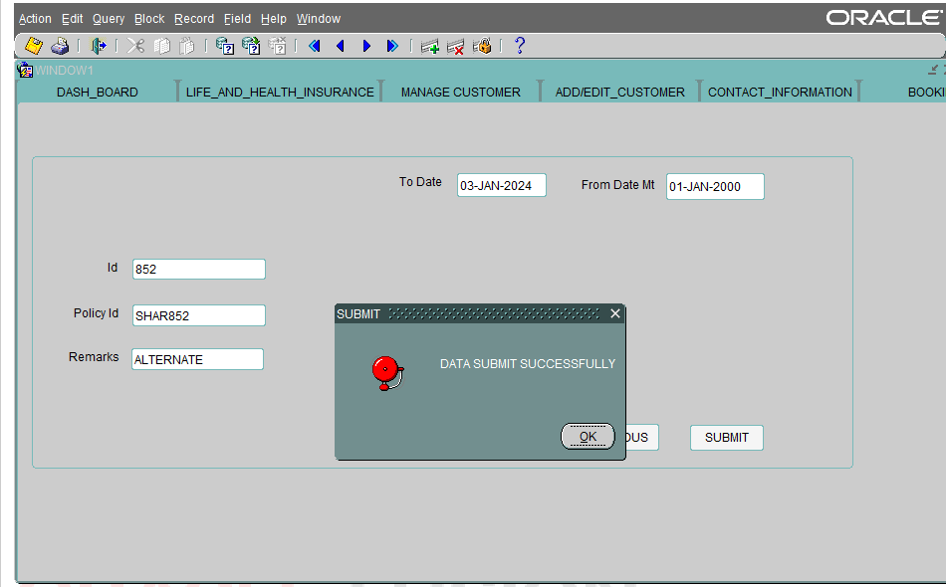

Click submit button.

The “DATA SUMIT SUCCESSFULLY” dialogue box appears.

Click OK to continue.

**STEP – 12**

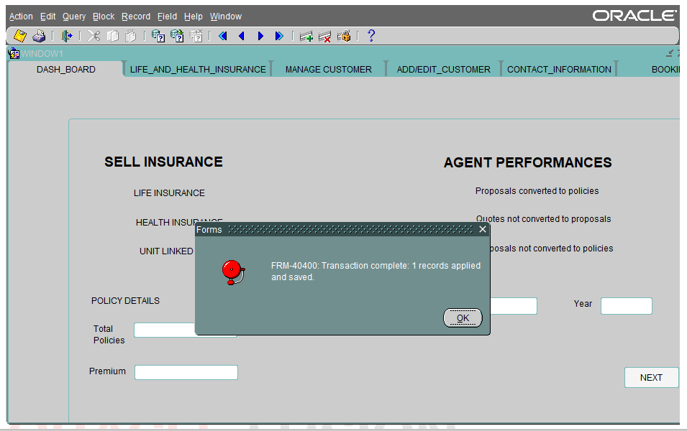

“TRANSACTION COMPLETE” dialogue box appears.

**STEP – 13**

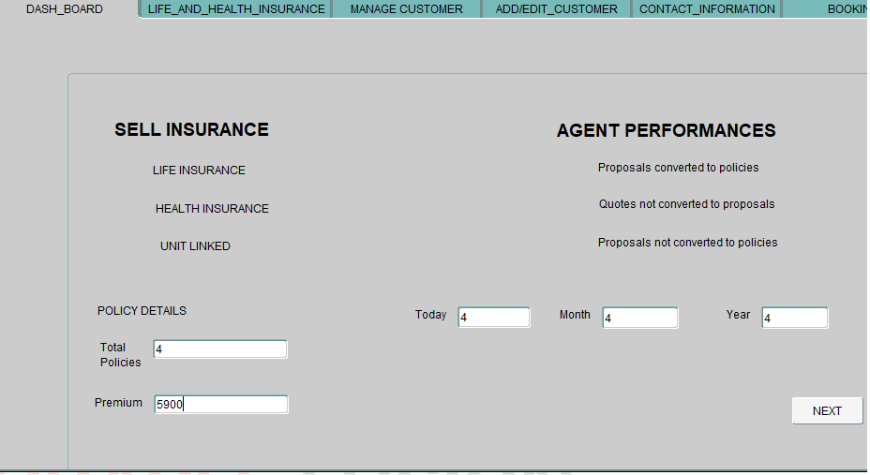

The Total policies, today, month, year, premium sold by the agent are auto populated.

|  |  |
| --- | --- |
| **AGENCY – TEST SCENARIOS** | |
| **SCENARIO – 3** | **Verify customer registration with gender "MALE"** |

**STEP – 1**



Enter the policy details.

Today, Month, Year includes the values of “total number of policies” sold by agent.

Enter the values in total policies, premium, today, month, year.

Click “NEXT” button to continue the process.

**STEP – 2**

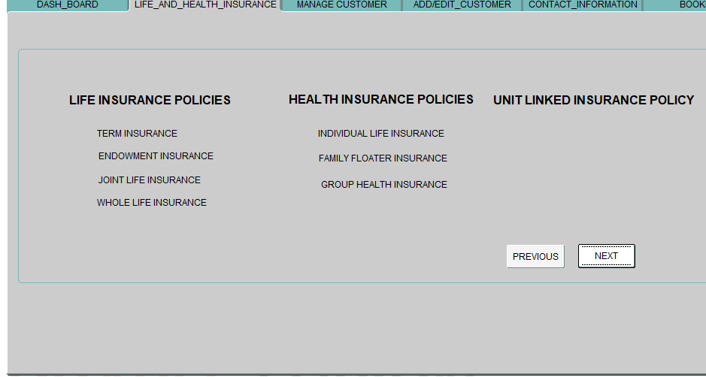

The “LIFE AND HEALTH INSURANCE” tab shows the list of life insurance, health insurance, unit linked insurance policies sold by the agent.

**STEP – 3**

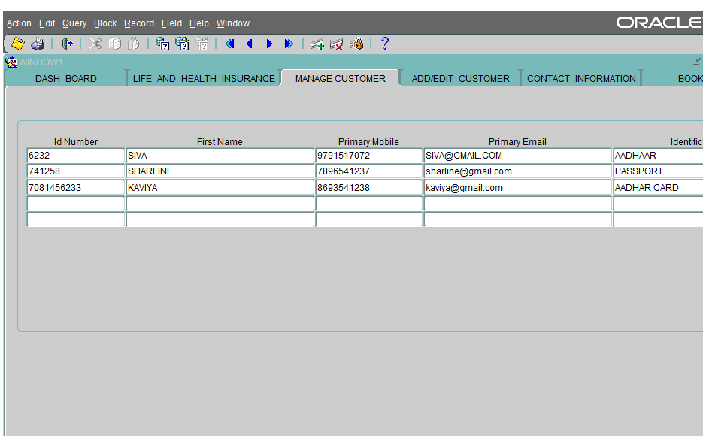

The customers who are registered by agent will be auto populated in ”MANAGE CUSTOMER” tab.

**STEP – 4**

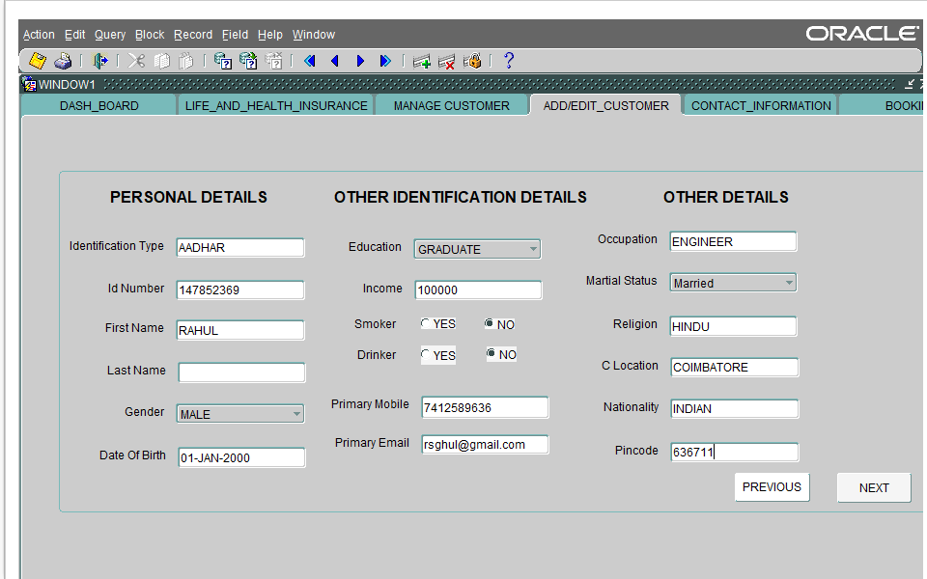

Fill the necessary details of the customer in the “ADD/EDIT CUSTOMER” tab. Choose gender as MALE.

Click the “NEXT” button to continue the process.

**STEP – 5**

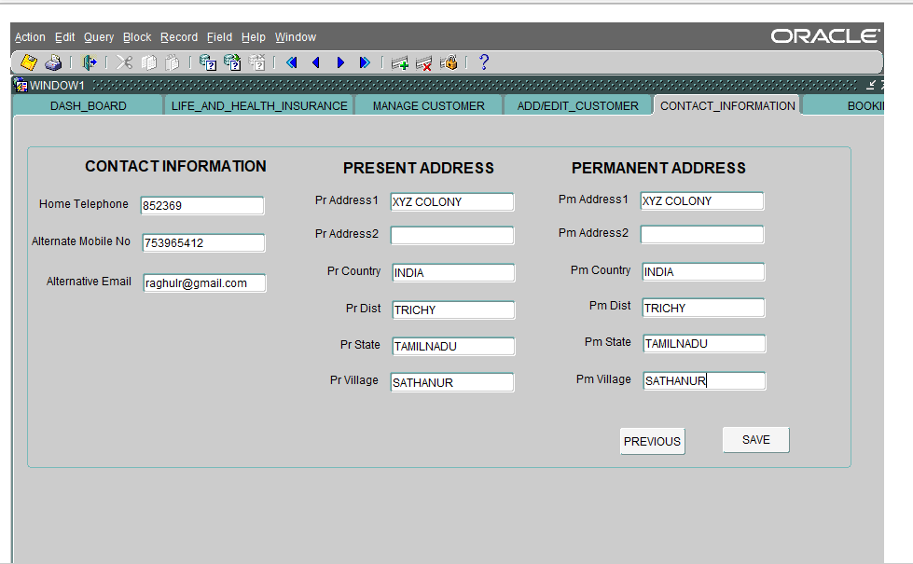

Fill the respective address details of the customer in the “CONTACT_INFORMATION” tab.

**STEP – 6**

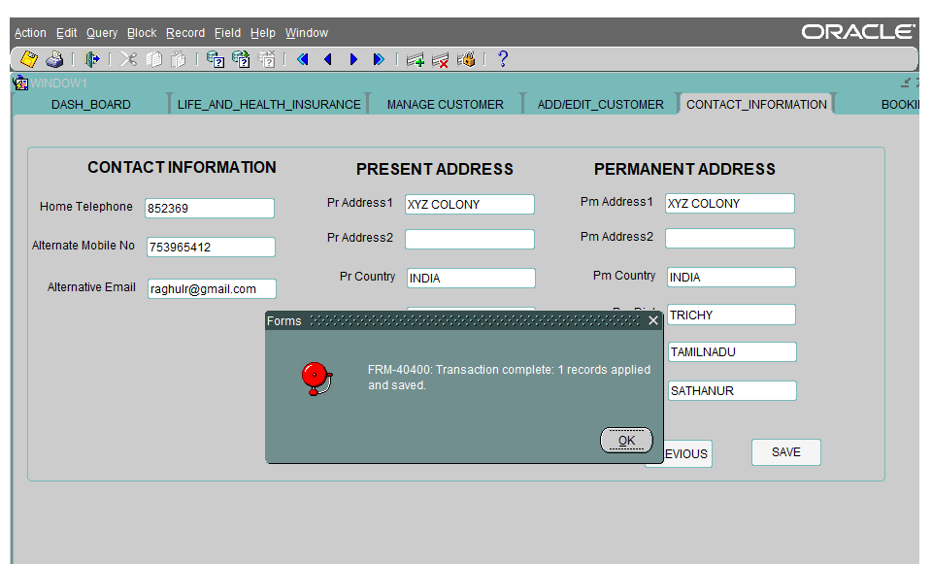

Click “SAVE” button to continue the process.

The “TRANSACTION COMPLETED” dialogue box appears.

**STEP -7**

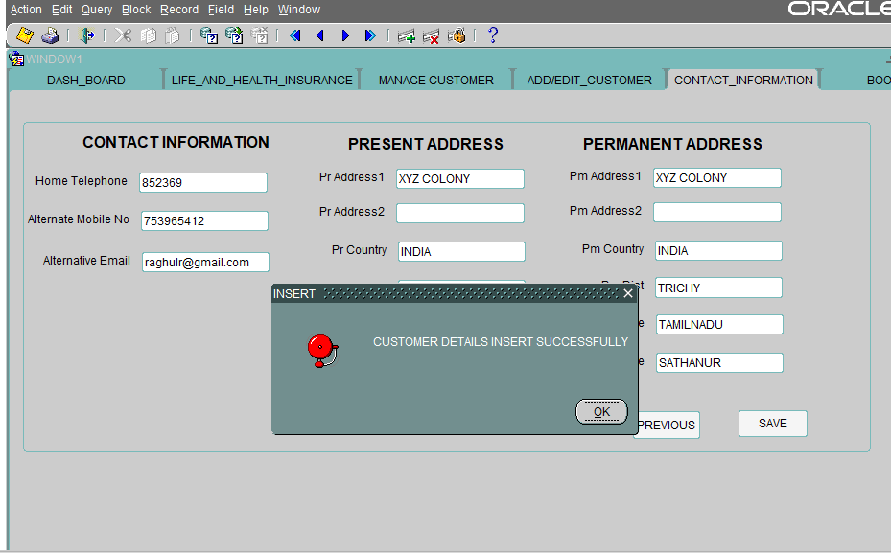

Click OK to continue.

“CUSTOMER DETAILS INSERTED SUCCESSFULLY” dialogue box appears.

**STEP – 8**

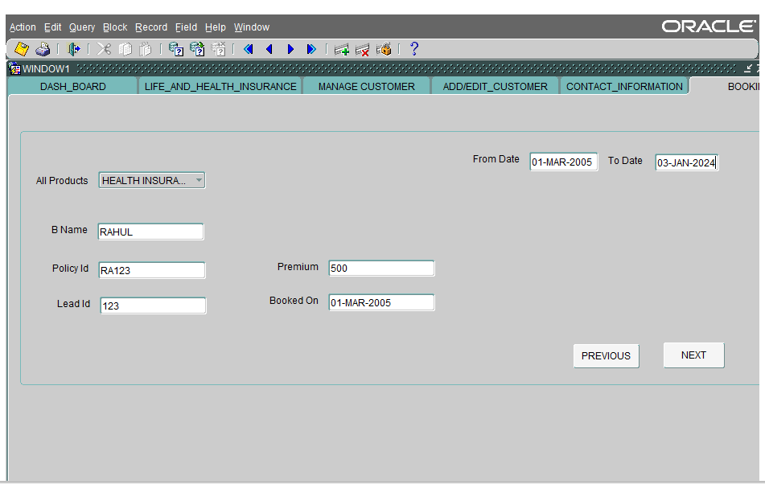

Select an insurance product from the list of values.

Enter the name, policy ID, Premium, Lead ID .

Enter the date in Booked on block.

Enter the From date, to date.

**STEP – 9**

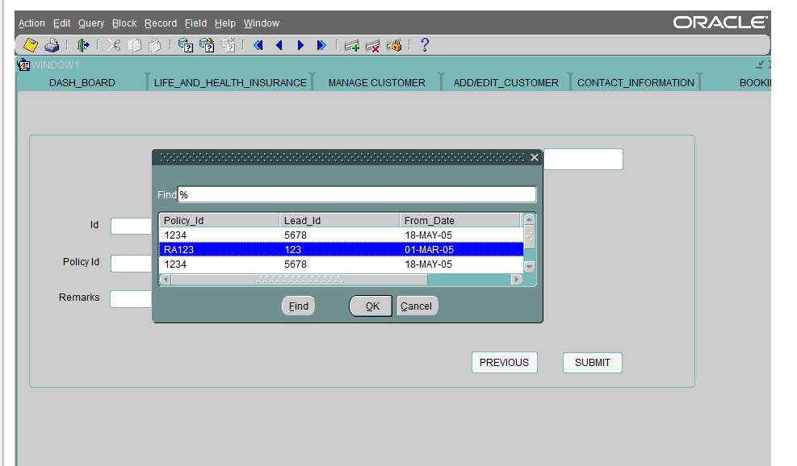

Click NEXT button to continue.

The Customer who has been registered by the agent will appear in the above dialogue box.

**STEP – 10**

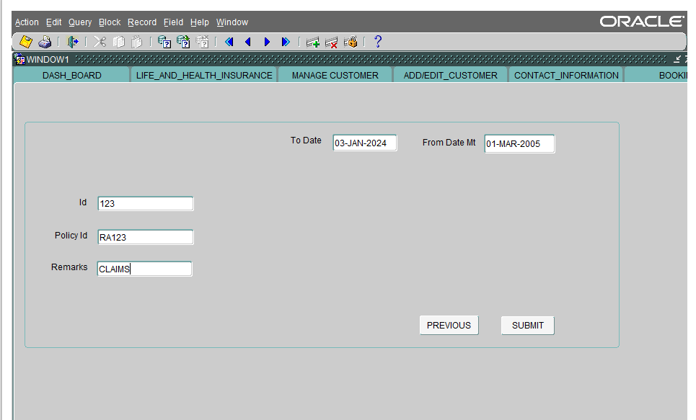

Enter the value for remarks

The other details will be auto populated in my tickets screen.

**STEP – 11**

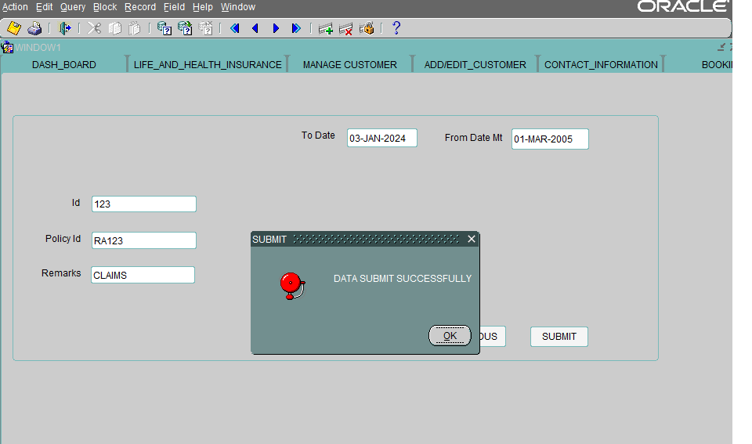

Click submit button.

The “DATA SUMIT SUCCESSFULLY” dialogue box appears.

Click OK to continue.

**STEP – 12**

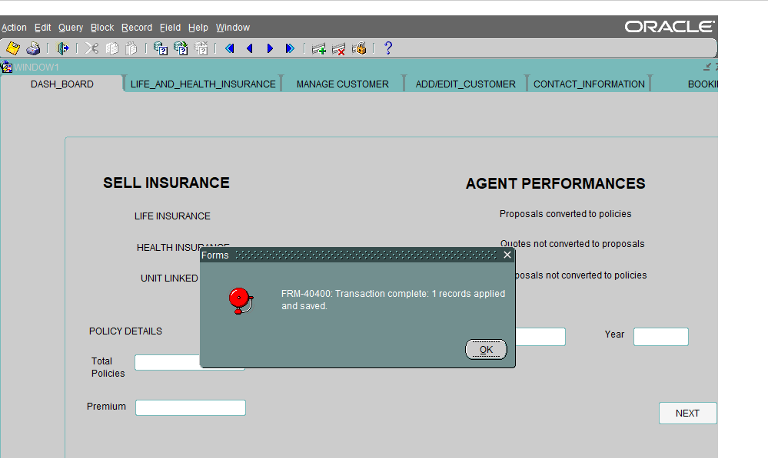

“TRANSACTION COMPLETE” dialogue box appears.

**STEP – 13**

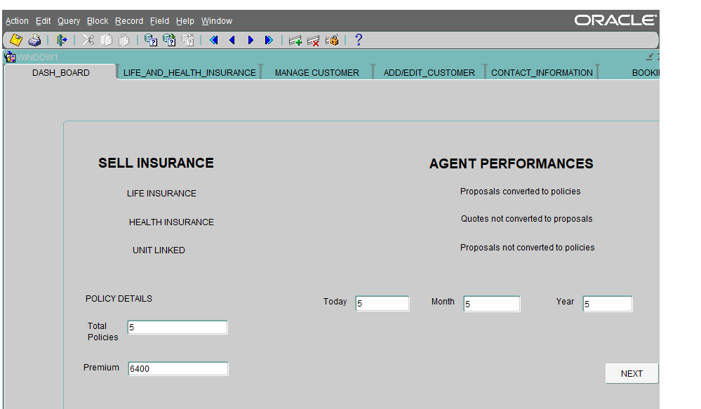

The Total policies, today, month, year, premium sold by the agent are auto populated.

|  |  |
| --- | --- |
| **AGENCY – TEST SCENARIOS** | |
| **SCENARIO – 4** | **Verify customer registration with "SMOKER"** |

**STEP -1**

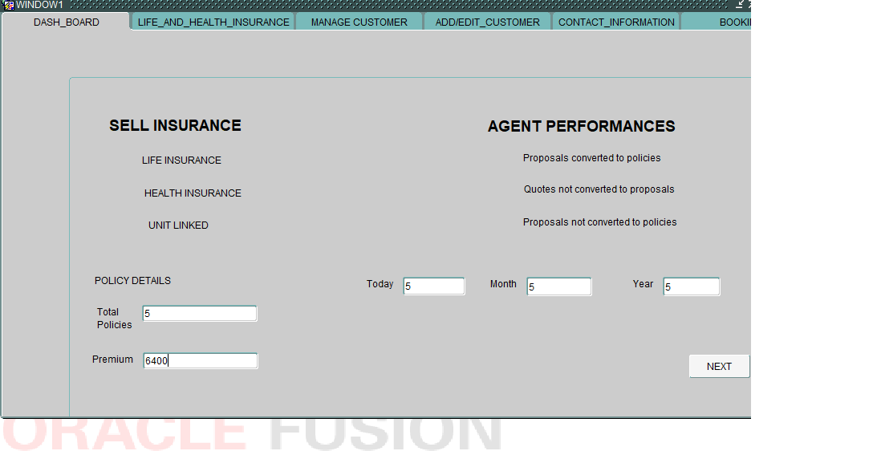

Enter the policy details.

Today, Month, Year includes the values of “total number of policies” sold by agent.

Enter the values in total policies, premium, today, month, year.

Click “NEXT” button to continue the process.

**STEP – 2**

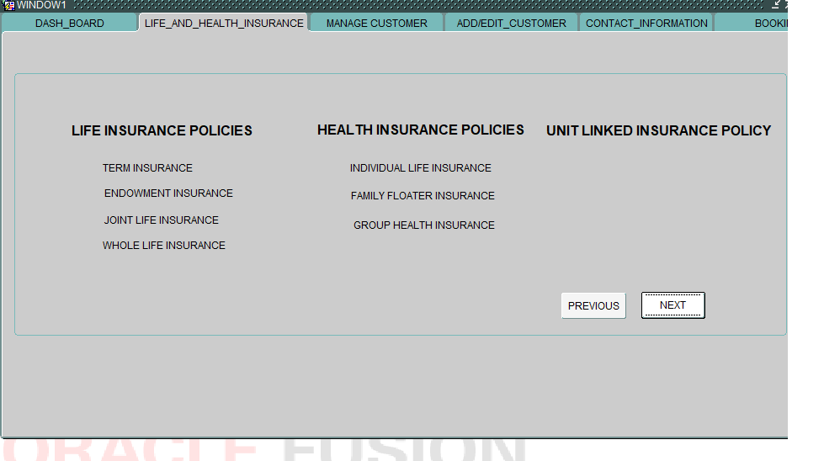

The “LIFE AND HEALTH INSURANCE” tab shows the list of life insurance, health insurance, unit linked insurance policies sold by the agent.

**STEP – 3**

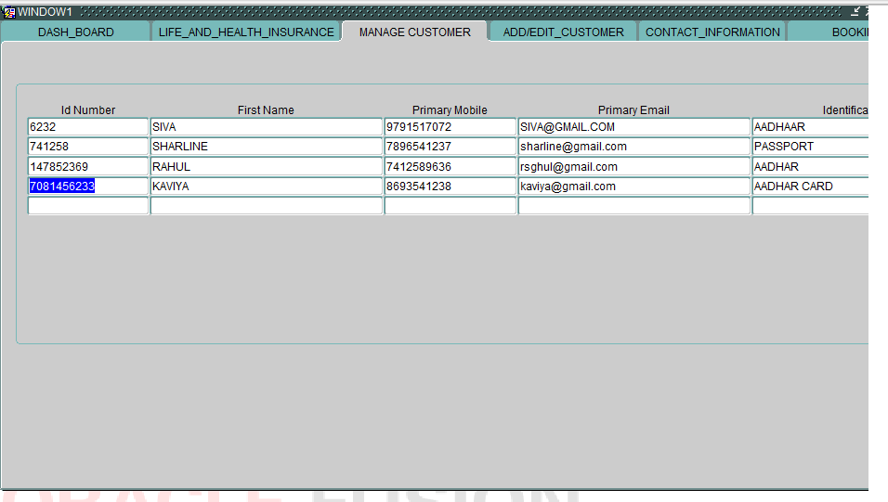

The customers who are registered by agent will be auto populated in ”MANAGE CUSTOMER” tab.

**STEP – 4**

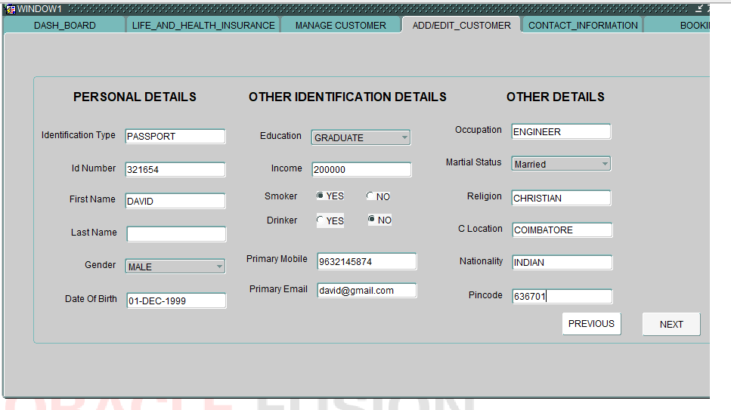

Fill the necessary details of the customer in the “ADD/EDIT CUSTOMER” tab. Choose “smoker” as YES

Click the “NEXT” button to continue the process.

**STEP – 5**

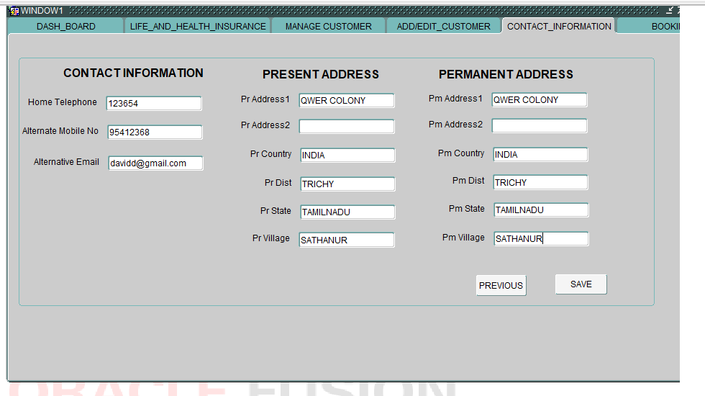

Fill the respective address details of the customer in the “CONTACT_INFORMATION” tab.

**STEP – 6**

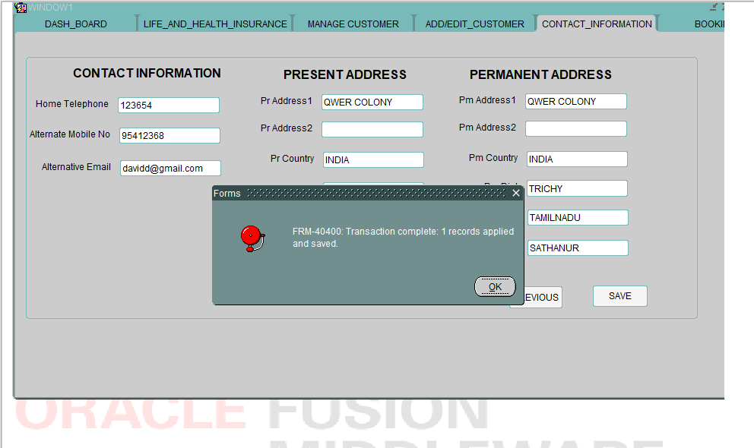

Click “SAVE” button to continue the process.

The “TRANSACTION COMPLETED” dialogue box appears.

**STEP – 7**

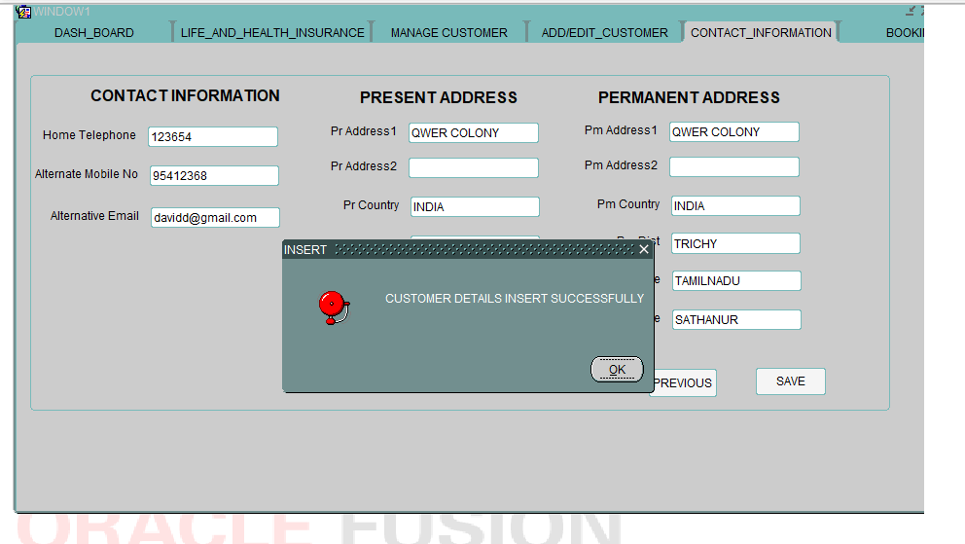

Click OK to continue.

“CUSTOMER DETAILS INSERTED SUCCESSFULLY” dialogue box appears.

**STEP – 8**

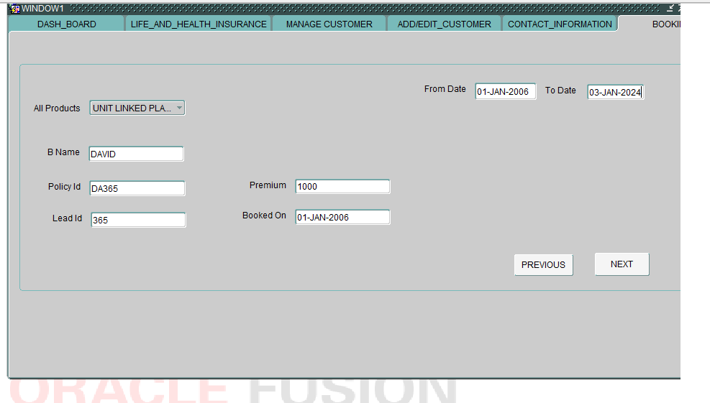

Select an insurance product from the list of values.

Enter the name, policy ID, Premium, Lead ID .

Enter the date in Booked on block.

Enter the From date, to date.

**STEP – 9**

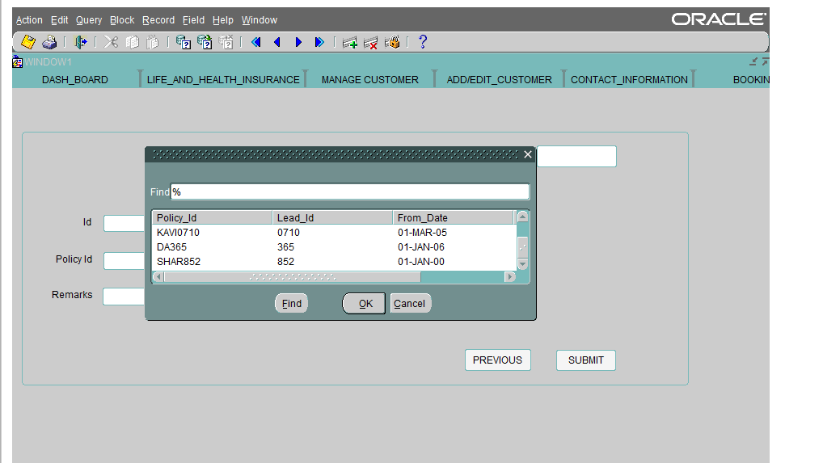

Click NEXT button to continue.

The Customer who has been registered by the agent will appear in the above dialogue box.

**STEP – 10**

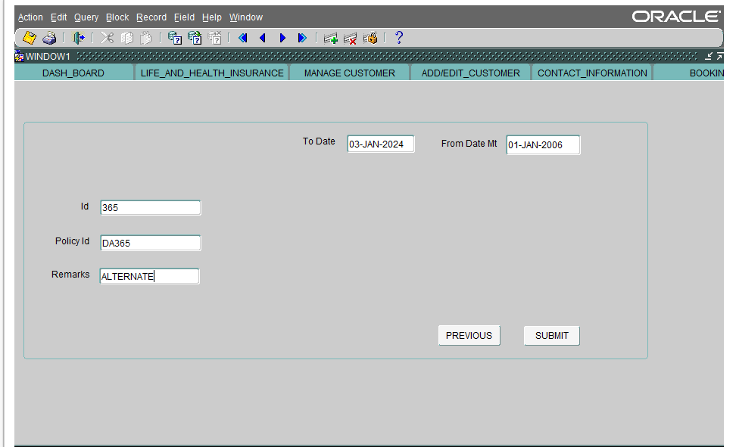

Enter the value for remarks

The other details will be auto populated in my tickets screen.

**STEP – 11**

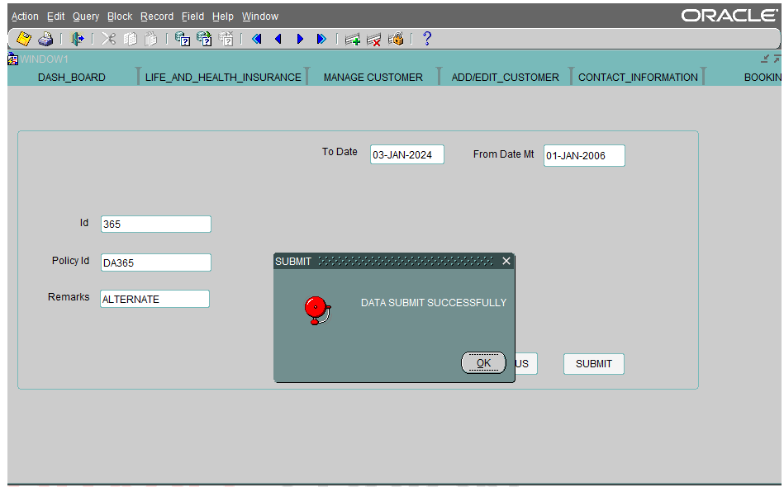

Click submit button.

The “DATA SUMIT SUCCESSFULLY” dialogue box appears.

Click OK to continue.

**STEP – 12**

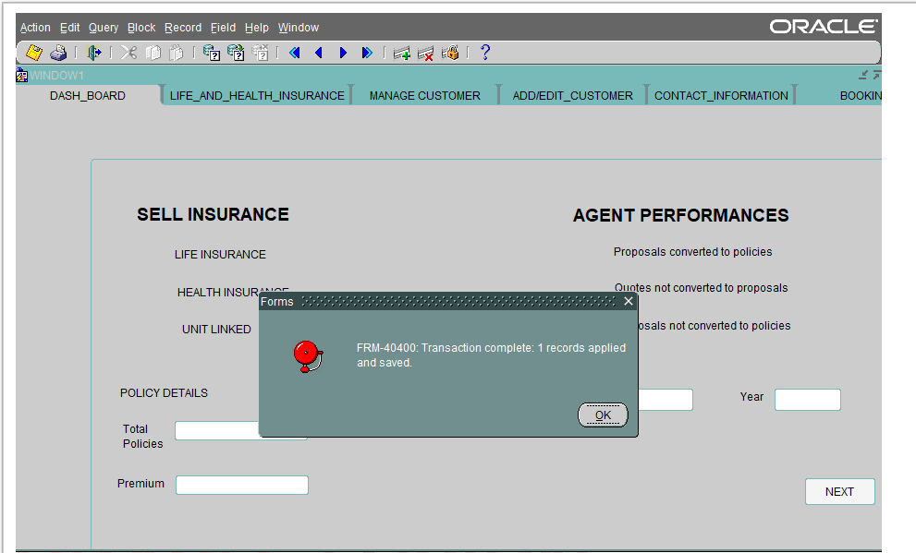

“TRANSACTION COMPLETE” dialogue box appears

**STEP – 13**

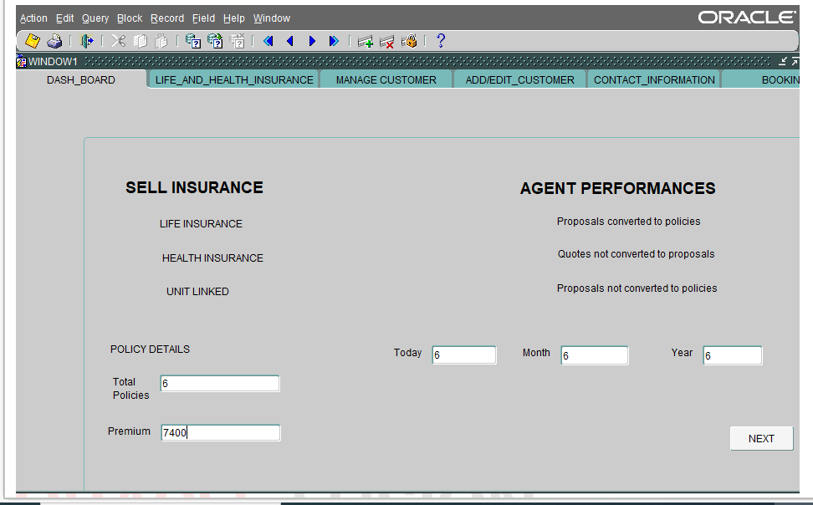

The Total policies, today, month, year, premium sold by the agent are auto populated.

|  |  |
| --- | --- |
| **AGENCY – TEST SCENARIOS** | |
| **SCENARIO – 5** | **Verify customer registration with "DRINKER"** |

**STEP – 1**



Enter the policy details.

Today, Month, Year includes the values of “total number of policies” sold by agent.

Enter the values in total policies, premium, today, month, year.

Click “NEXT” button to continue the process.

**STEP – 2**

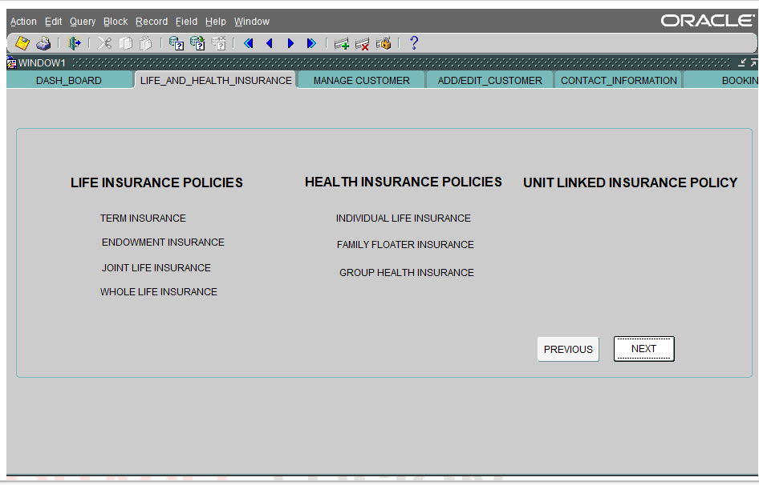

The “LIFE AND HEALTH INSURANCE” tab shows the list of life insurance, health insurance, unit linked insurance policies sold by the agent.

**STEP – 3**

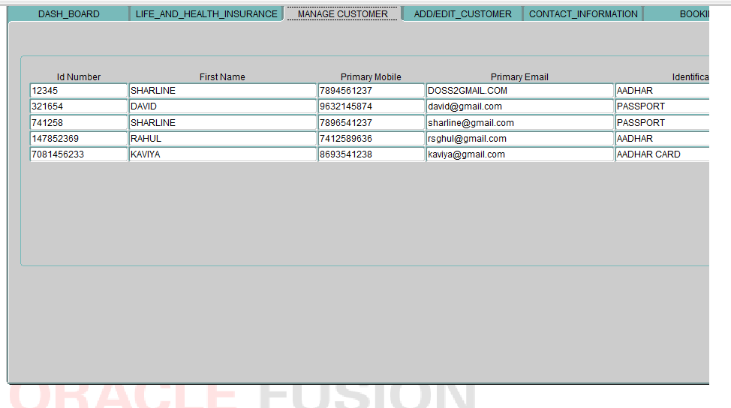

The customers who are registered by agent will be auto populated in ”MANAGE CUSTOMER” tab.

**STEP – 4**

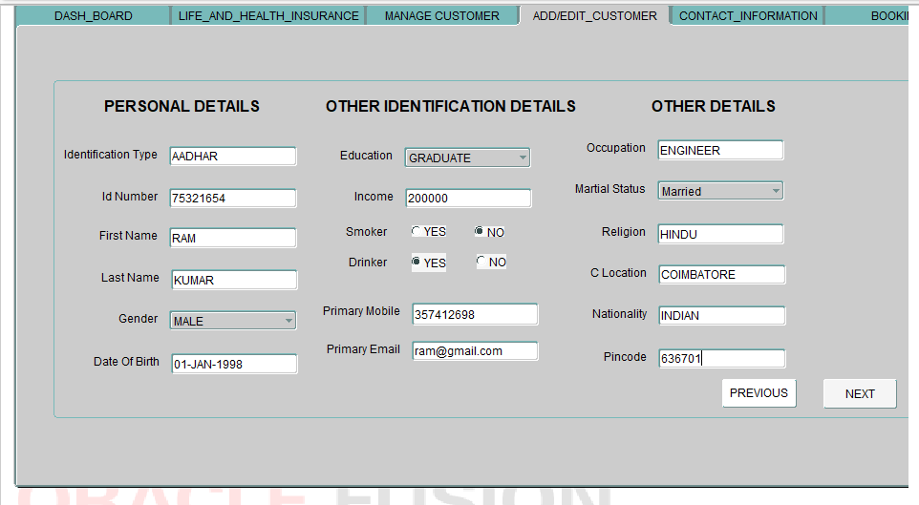

Fill the necessary details of the customer in the “ADD/EDIT CUSTOMER” tab.

Click the “NEXT” button to continue the process.

**STEP – 5**

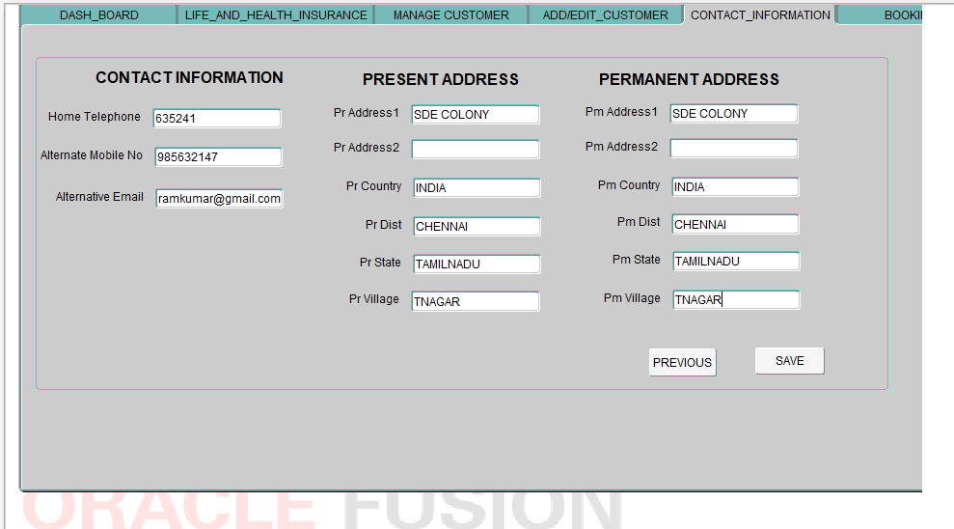

Fill the respective address details of the customer in the “CONTACT_INFORMATION” tab.

**STEP – 6**

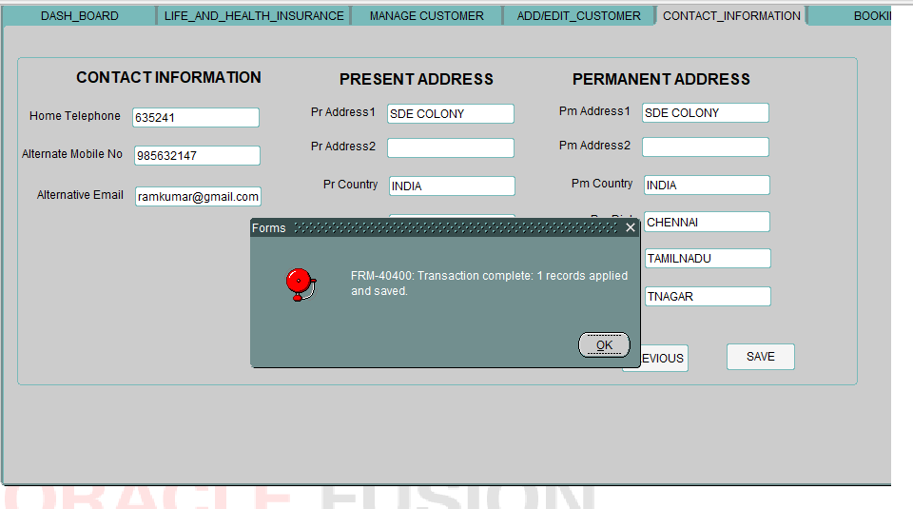

Click “SAVE” button to continue the process.

The “TRANSACTION COMPLETED” dialogue box appears.

**STEP – 7**

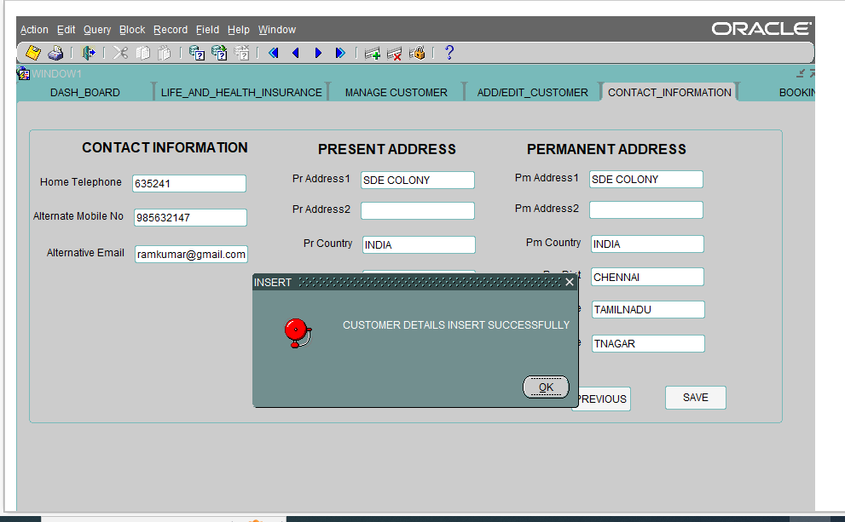

Click OK to continue.

“CUSTOMER DETAILS INSERTED SUCCESSFULLY” dialogue box appears.

**STEP – 8**

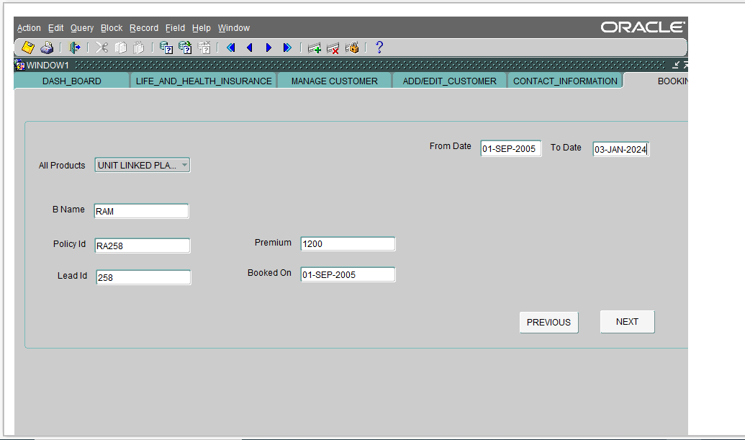

Select an insurance product from the list of values.

Enter the name, policy ID, Premium, Lead ID .

Enter the date in Booked on block.

Enter the From date, to date.

**STEP – 9**

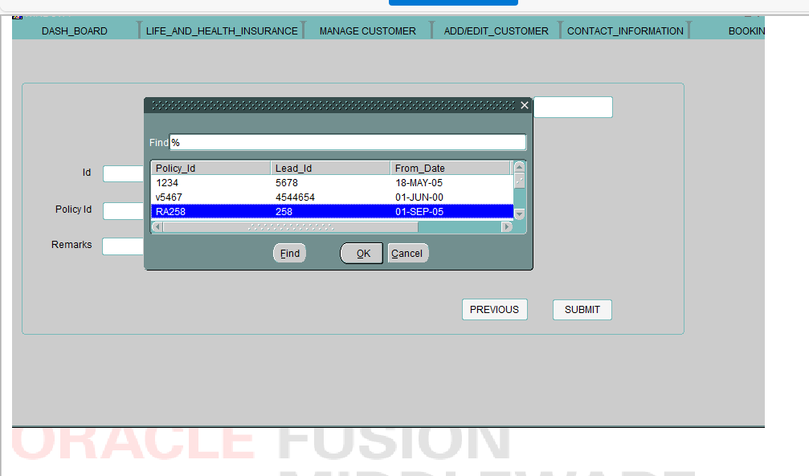

Click NEXT button to continue.

The Customer who has been registered by the agent will appear in the above dialogue box.

**STEP – 10**

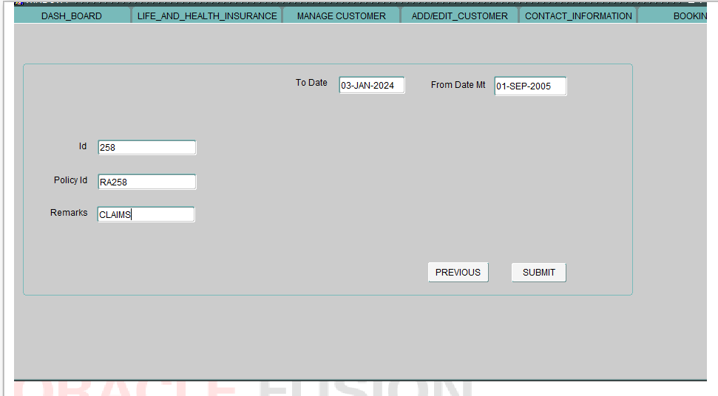

Enter the value for remarks

The other details will be auto populated in my tickets screen.

**STEP – 11**

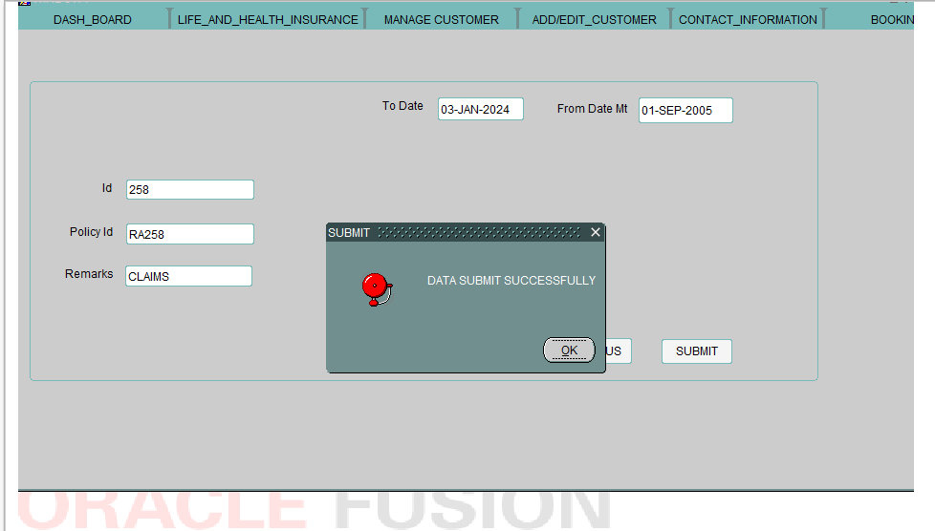

Click submit button.

The “DATA SUMIT SUCCESSFULLY” dialogue box appears.

Click OK to continue.

**STEP – 12**

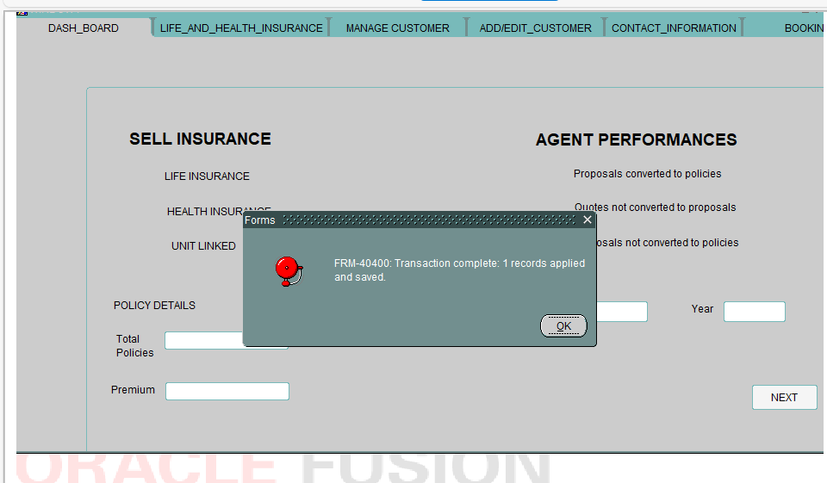

“TRANSACTION COMPLETE” dialogue box appears

**STEP – 13**

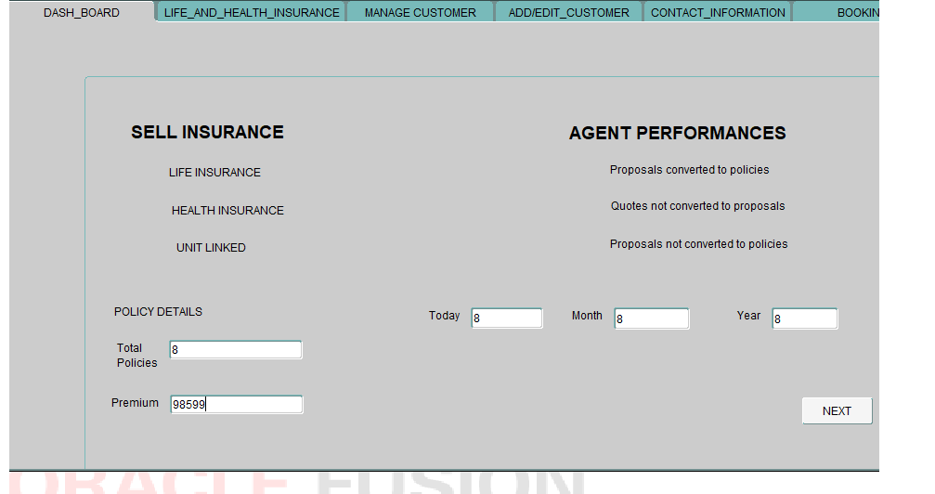

The Total policies, today, month, year, premium sold by the agent are auto populated.

|  |  |
| --- | --- |
| **AGENCY – TEST SCENARIOS** | |
| **SCENARIO – 6** | **Verify customer registration marital status with "UNMARRIED"** |

**STEP – 1**

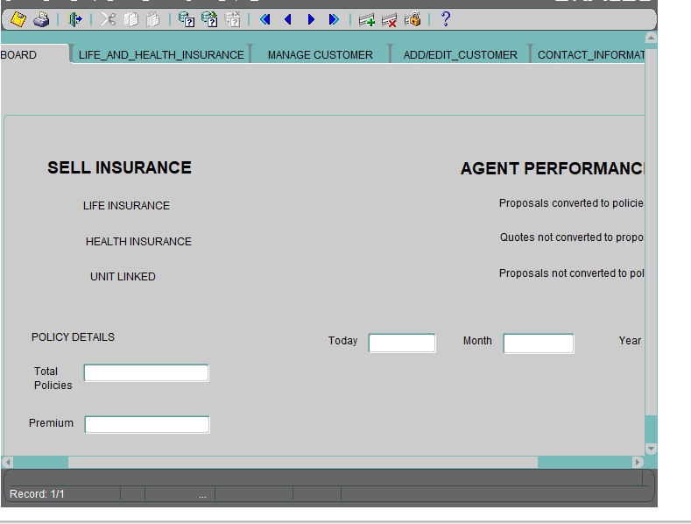

Enter the policy details.

Today, Month, Year includes the values of “total number of policies” sold by agent.

Enter the values in total policies, premium, today, month, year.

Click “NEXT” button to continue the process.

**STEP – 2**

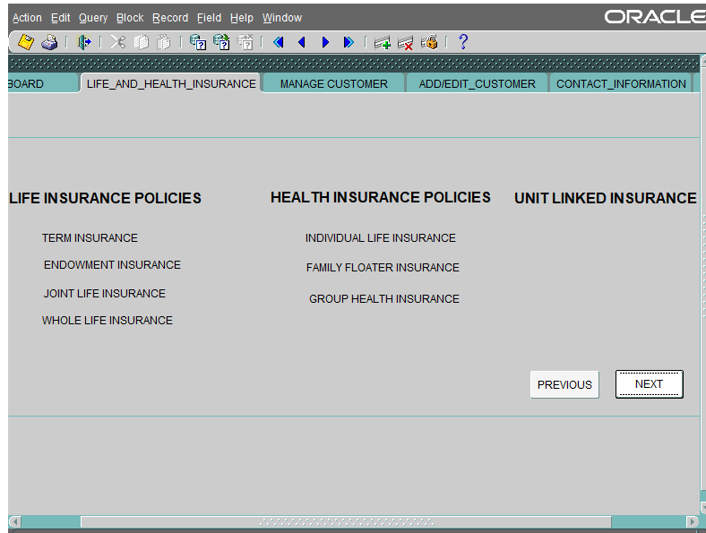

The “LIFE AND HEALTH INSURANCE” tab shows the list of life insurance, health insurance, unit linked insurance policies sold by the agent.

**STEP – 3**

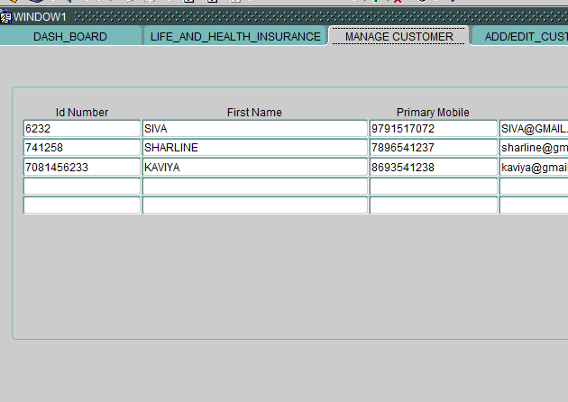

The customers who are registered by agent will be auto populated in ”MANAGE CUSTOMER” tab.

**STEP – 4**

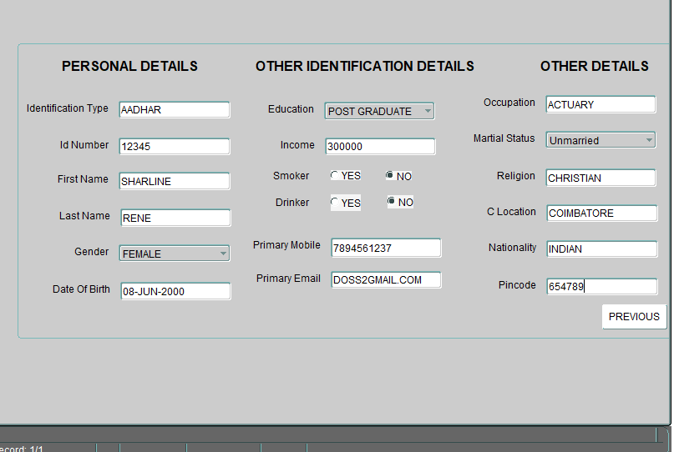

Fill the necessary details of the customer in the “ADD/EDIT CUSTOMER” tab.

Click the “NEXT” button to continue the process.

**STEP – 5**

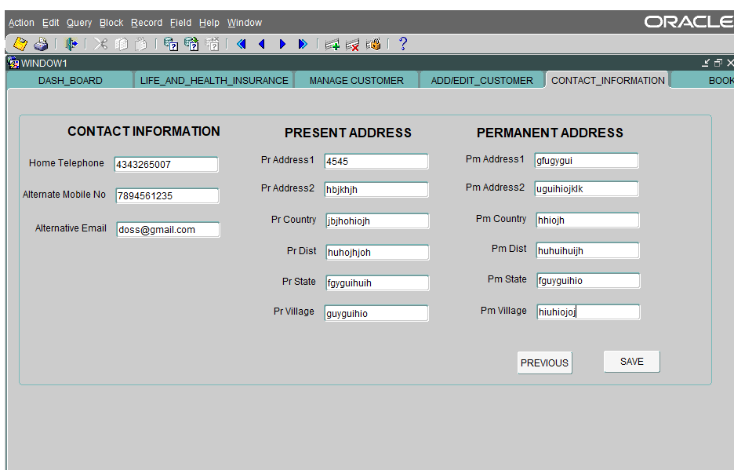

Fill the respective address details of the customer in the “CONTACT_INFORMATION” tab.

**STEP – 6**

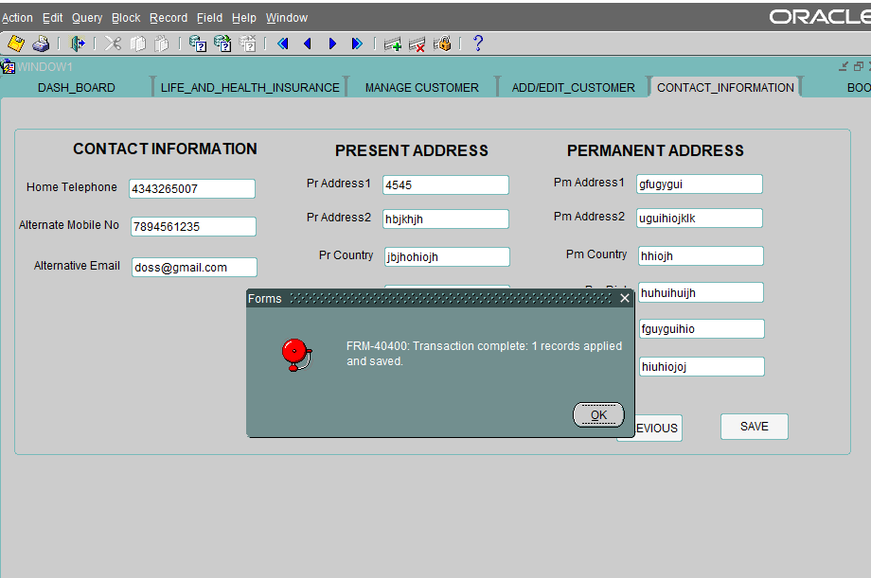

Click “SAVE” button to continue the process.

The “TRANSACTION COMPLETED” dialogue box appears.

**STEP – 7**

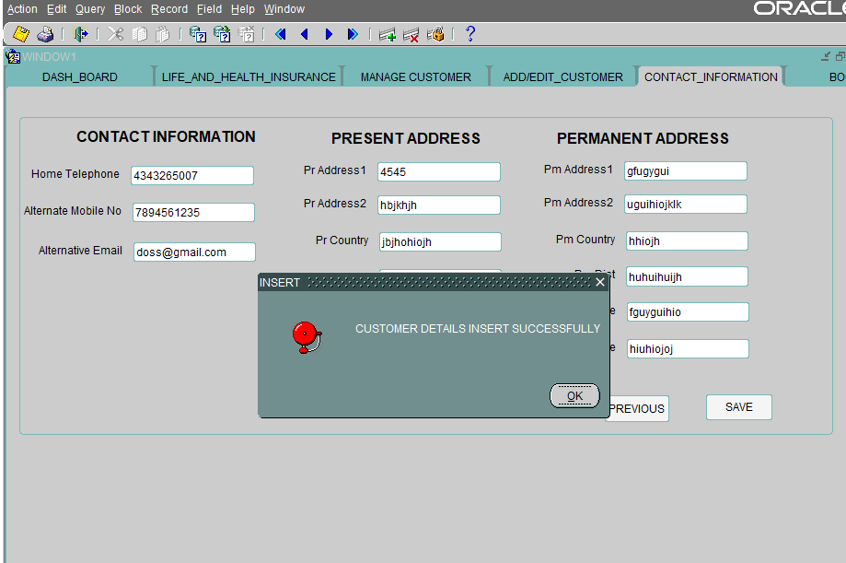

Click OK to continue.

“CUSTOMER DETAILS INSERTED SUCCESSFULLY” dialogue box appears.

**STEP – 8**

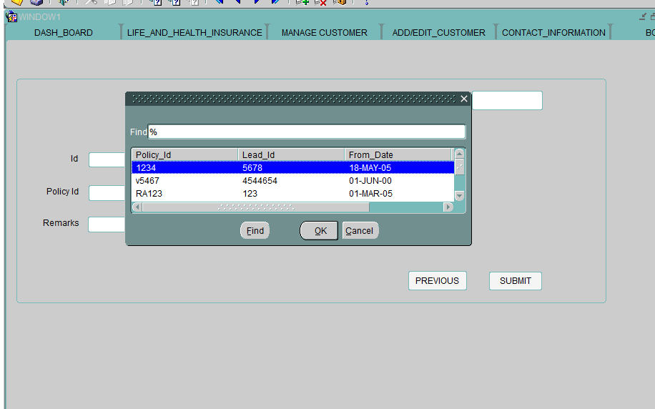

Select an insurance product from the list of values.

Enter the name, policy ID, Premium, Lead ID .

Enter the date in Booked on block.

Enter the From date, to date.

Click NEXT button to continue.

The Customer who has been registered by the agent will appear in the above dialogue box.

**STEP – 9**

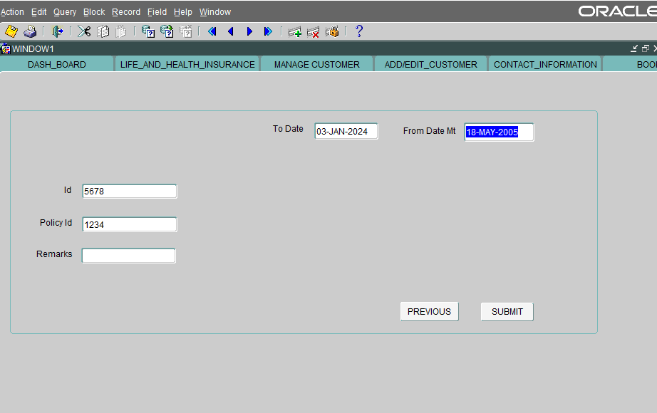

Enter the remarks as “CLAIMS”

The other details will be auto populated in my tickets screen.

**STEP -10**

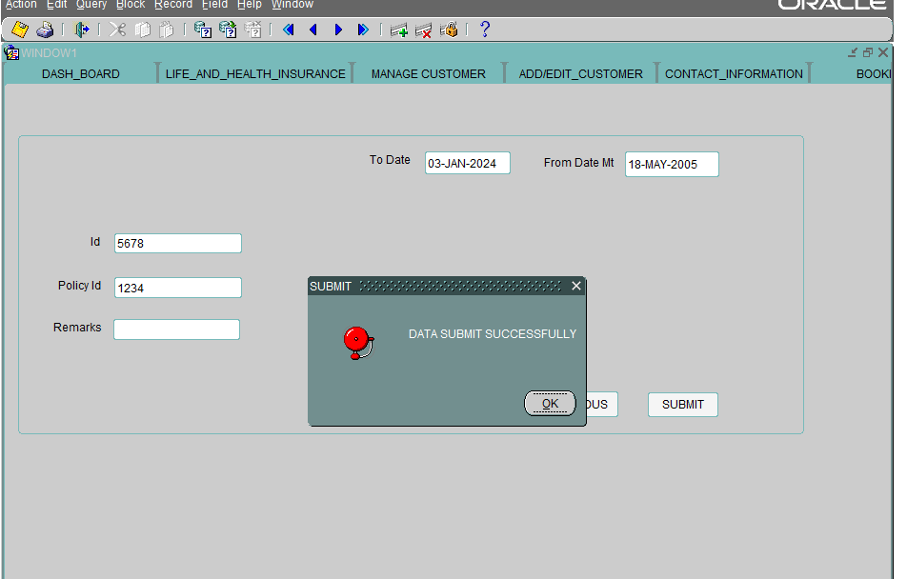

Click submit button.

The “DATA SUMIT SUCCESSFULLY” dialogue box appears.

Click OK to continue.

**STEP – 11**



“TRANSACTION COMPLETE” dialogue box appears

The Total policies, today, month, year, premium sold by the agent are auto populated.